Question 1/4: Vectors (5 points)
Write a method void duplicate(int elem) on the Vector class that traverses the vector and (in-place) duplicates all values elem without creating or using an additional vector (or any other data structure).
For example, calling duplicate(3) on the following vector

[1, 2, 3, 2, 4, 3, 1]

will result in a vector containing the following elements:

[1, 2, 3, 3, 2, 4, 3, 3, 1]

What is the time complexity of your algorithm? Motivate your answer.

Question 2/4: Trees (6 points)
Level order traversal is a traversal algorithm that visits tree nodes in order of depth, i.e. visiting first the root, then all the nodes from the second level (depth 1), etc. Write the level order traversal method that visits nodes based on the depth (top-down) and left to right. For instance, for this tree
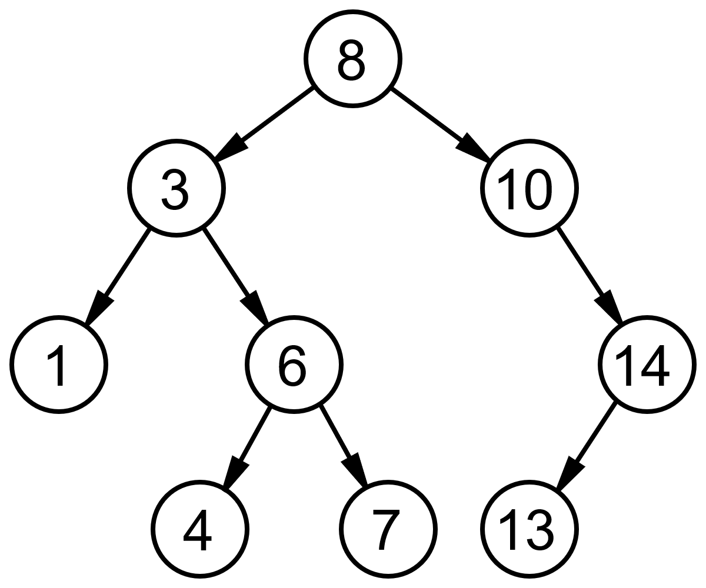
the traversal order will be:
Level 1: 8
Level 2: 3, 10
Level 3: 1, 6, 14
Level 4: 4, 7, 13
What is the time complexity of your method? Motivate your answer.

Question 3/4 (4 points)
Assume a circular structure called Circular double linked list. This structure is similar to Double linked list, but the elements are chained in a circle, meaning the predecessor of the first element is the last element and the successor of the last element is the first element. Write the methods addFirst(...), addLast(), removeFirst(), removeLast() and contains(Object val).

Question 4/4: (5 points)
Consider a directed acyclic graph. A “transpose” of a graph is the same graph, with all edges transposed, i.e. an edge from node i to node j is transposed into an edge from node j to node i. Write a transpose method on a graph in adjacency matrix representation. Give and motivate the time complexity of the method.

Provided Code

Linked List

public class LinkedList implements Comparable{
class ListElement
{
private Comparable el1;
private ListElement el2;

public ListElement(Comparable el, ListElement nextElement)
{
el1 = el;
el2 = nextElement;
}

public ListElement(Comparable el)
{
this(el,null);
}

public Comparable first()
{
return el1;
}

public ListElement rest()
{
return el2;
}

public void setFirst(Comparable value)
{
el1 = value;
}

public void setRest(ListElement value)
{
el2 = value;
}
}

protected ListElement head;
private int count = 0;

public LinkedList()
{
head = null;
}

public String toString()
{
String result = "(";
ListElement d = head;
while(d != null)
{
result += d.first().toString();
result += " ";
d = d.rest();
}
result += ")";
return result;
}
}

Stack
public class Stack {

private LinkedList data;

public Stack()
{
data = new LinkedList();
}

public void push(Comparable o)
{
data.addFirst(o);
}

public Comparable pop()
{
if(data.empty()) return null;
else return data.removeFirst();
}

public Comparable top()
{
return data.getFirst();
}

…
}

Binary Tree

public class Tree {

public class TreeNode implements Comparable {
protected Comparable value;
protected TreeNode leftNode, rightNode;
public TreeNode(Comparable v) {
value = v;
leftNode = null;
rightNode = null;
}
public TreeNode(Comparable v, TreeNode left, TreeNode right) {
value = v;
leftNode = left;
rightNode = right;
}
public TreeNode getLeftTree() { return leftNode; }

public TreeNode getRightTree() { return rightNode; }

public Comparable getValue() { return value; }
}
protected TreeNode root;
public Tree() {
root = null;
}
public void traverseNode(TreeNode n, TreeAction action) {
if(n != null) {
if(n.getLeftTree() != null) traverseNode(n.getLeftTree(),action);
action.run(n);
if(n.getRightTree() != null) traverseNode(n.getRightTree(),action);
}
}
public void traverseInOrder(TreeAction action) {
traverseNode(root,action);
}
public void traverse(TreeAction action){
Stack t = new Stack();
t.push(root);
while(!t.empty()) {
TreeNode n = (TreeNode)t.pop();
action.run(n);
if(n.getLeftTree() != null) t.push(n.getLeftTree());
if(n.getRightTree() != null) t.push(n.getRightTree());
}
}
}

Graph
public class Graph
{
public class Node implements Comparable
{
private Comparable info;
private Vector edges;

public Node(Comparable label)
{
info = label;
edges = new Vector();
}

public void addEdge(Edge e)
{
edges.addLast(e);
}

public int compareTo(Object o){ ... }

public Comparable getLabel()
{
return info;
}
}

private class Edge implements Comparable
{
private Node toNode;

public Edge(Node to)
{
toNode = to;
}

public int compareTo(Object o){ ... }
}

private Vector nodes;

public Graph()
{
nodes = new Vector();
}

public void addNode(Comparable label)
{
nodes.addLast(new Node(label));
}

public void addEdge(Comparable nodeLabel1, Comparable nodeLabel2)
{
Node n1 = findNode(nodeLabel1);
Node n2 = findNode(nodeLabel2);
n1.addEdge(new Edge(n2));
}
}

